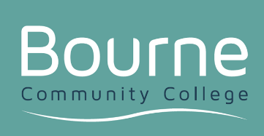

THE BOURNE COMMUNITY COLLEGE
PERSON SPECIFICATION – TEACHER

Successful candidates will possess the following attributes:
- Demonstrate ability to be an outstanding teacher or a strongly ‘good’ teacher/educational support member, with clear capacity to improve

- Clear potential to progress in their career

- Possession of a wide range of skills to support staff, students, parents and community towards absolute excellence

- The skills, experience and ability to gain the confidence of students and staff

- Professional presence, capability and clarity with an excellent demonstration of the ability to motivate and empower

- A clear sense of fun, energy, drive and passion

- A willingness to innovate and operate outside of the ‘normal’ expectations of a school

- A desire to be ‘the best’ and the ability to translate an aspiration to be the best

- The ability to demonstrate engagement of students, manage their behaviour, attitudes and aspirations, whilst maintaining an un-erring high expectation and focus upon mutually respectful positive relationships

- Excellent knowledge of effective strategies to raise achievement and excellence in teaching and learning

Aspiration, Innovation, Motivation

March 2019

