**Bourne Community College**

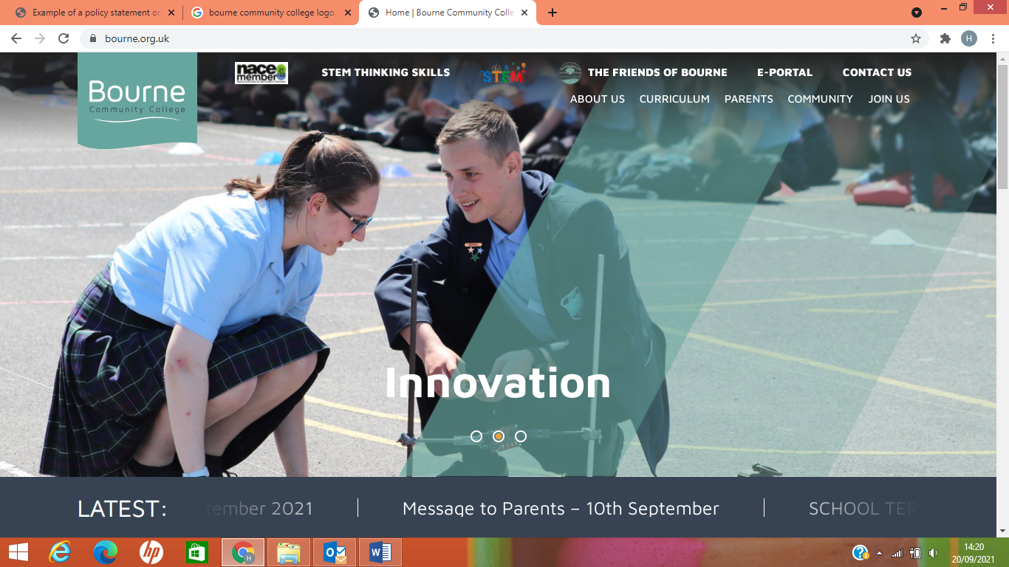

**Provider Access Policy (Baker Clause)**

**Introduction**

This policy statement sets out the college’s arrangements for managing the access of providers to students at the college for the purposes of giving them information about the provider’s education or training offer. This complies with the College’s legal obligations under Section 42B of the Education Act 1997 (Baker Clause)

**Student entitlement**

All our students are entitled:

• To find out about technical education qualifications and apprenticeships opportunities, as part of a careers programme which provides information on the full range of education and training options available at each transition point.

• To hear from a range of local providers about the opportunities they offer, including technical education and apprenticeships – through focused open events including career fairs, further education provider visits, group discussions and taster events.

• To understand how to make applications for the full range of academic and technical courses.

**Management of provider access requests**

Procedure:

A provider wishing to request access should contact Helena Jewer, Leader of Careers

Telephone: 01243 375691 Email: [hjewer@bourne.org.uk](mailto:hjewer@bourne.org.uk)

**Opportunities for access**

Varied events, integrated into the college’s careers programme, will offer providers an opportunity to come into campuses to speak to students:

|  |  |  |  |
| --- | --- | --- | --- |
| Examples of opportunities available for employers/providers to attend | | | |
| Across Years 7-9 | Opportunities for promoting jobs/ careers within the PSHE curriculum | Employer/Provider visits to group sessions |  |
| Year 10 / 11 | Opportunities for promoting jobs/ careers within the curriculum  Opportunity for work experience | College taster sessions and visits | College and Apprenticeship applications |
| Other | Annual Career Fair  Focussed days | Exam results days: opportunity to speak with further education providers | Careers Advice interviews |

Please speak to our named Careers Leader to identify the most suitable opportunity for you.

The college policies on visitors found at <https://www.bourne.org.uk/wp-content/uploads/Visitors-Policy-Sep-20.pdf> will be followed by any providers accessing our premises to talk to our students.

**Premises and facilities**

The college will make our premises available to allow fair access between the provider and students, as appropriate to the activity. The college will also make available IT and other specialist equipment, where possible, to support provider presentations. This will all be discussed and agreed in advance of the visit with the Careers Leader or a member of the IT Technical team.

Providers are welcome to leave a copy of their prospectus or other relevant course literature at our reception. This will be made available to students by being displayed at our Careers hubs within our College Library which has a dedicated careers area. The College Library is available to all students.

**Approval and review**

Approved: September 2021

Next review: July 2022





Signed: Yvonne Watkins – Head teacher