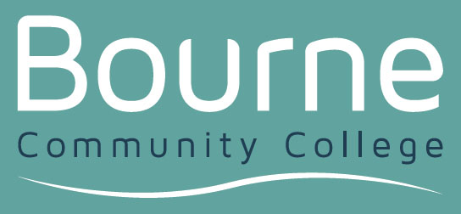

A Protocol to support parental engagement during the education journey for children and young people with special educational needs and/or disabilities

This Protocol has been developed at the request of parents, to support their engagement in the education journey for children with special educational needs and/or disabilities. It includes some principles that underpin their child’s education.

West Sussex County Council, parent carers, schools and colleges are all committed to using best endeavours to provide the best attainment and outcomes for children and young people with special educational needs and / or disabilities from age 0-25 (where appropriate).

Aims & Objectives
- To provide all children and young people with an education that is appropriate to their age, aptitude and ability
- To provide guidance for families regarding their child’s education
- To regularly involve children and young people and parent carers in an open and transparent planning process, working in co-production to support outcomes
- To help parent carers and children and young people to understand where and when practical help and support can be provided, including signposting to the SEND Information, Advice and Support Service (SEND IAS)
- To build confidence in joint plans, focusing on outcomes that are personalised for individual children

Principles
- Families are entitled to know what they can expect to happen at each stage of their child’s education journey; how parent carers and children and young people will be involved and what schools will do
- Everyone will work together to support pupil progress, and to enhance individual learning pathways
- Everyone is committed to open and honest communications; to consulting each other and to provide feedback as needed
- Parent carers are entitled to have ongoing involvement throughout their child’s education; to be involved in termly discussions, plans and decisions made, particularly during transition
- Everyone will ensure that the child or young person’s needs remain paramount, taking into account relevant law and guidance e.g. the Children and Families Act (part 3) and the SEND Code of Practice 2015

Implementation
This Protocol has been developed by parent carers, supported by West Sussex County Council. It cannot be implemented without the support of schools, colleges and other learning settings. All partners are asked to signal their commitment to this Protocol by adding their logo, posting it to their website and informing the SEND Information, Advice and Support Service by emailing SEND.IAS@westsussex.gov.uk.

Review - A review of this protocol will be led by the SEND Information, Advice and Support Service with parent carers, supported by WSCC, as and when there are significant changes.



December 2020

