BOURNE COMMUNITY COLLEGE

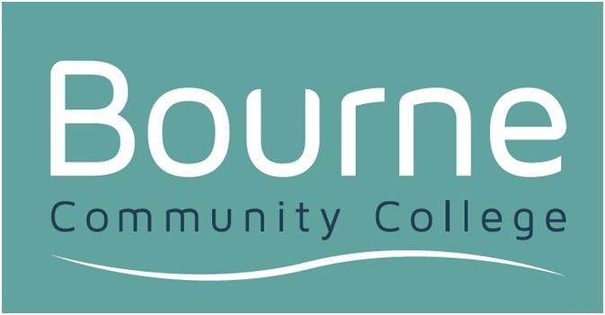

Aspiration, Innovation, Motivation

Sims Parent App
Acceptable Use Policy

Our Mission:
To ensure every student develops their potential to flourish and be successful
To have high expectations of all staff and students
To respect those in our community locally, nationally and internationally

Our Vision:
To be an outstanding school and the Learning Hub for the locality

AIM
This policy aims to encourage the safe use of SIMS Parent App.

POLICY
This Policy applies:
- wherever access to the Bourne SIMS Parent App is provided
- whenever information is accessed through the Bourne SIMS Parent App, whether the computer equipment used is owned by Bourne or not
- to all those who make use of Bourne SIMS Parent App

OBJECTIVES OF BOURNE SIMS PARENT APP ACCEPETBLE USE POLICY
This Policy is intended to minimise security risks. These risks might affect the integrity of Bourne data, the authorised SIMS Parent App user and the individuals to which the SIMS Parent App data pertains.

In particular these risks arise from:
- the intentional or unintentional disclosure of login credentials to the Bourne SIMS Parent App by authorised users
- the wrongful disclosure of private, sensitive, and confidential information
- exposure of Bourne to vicarious liability for information wrongfully disclosed by authorised users
- the unintentional provision of incorrect information such as a ‘guessed’ email addresses which may not work, but at worst, could actually belong to someone else

DATA ACCESS
This Policy aims to ensure all relevant aspects of the Data Protection Act (1998), GDPR and Fair Processing Policy are adhered to. This Policy aims to promote best use of the SIMS Parent App to further the communication and freedom of information between Bourne and Parents/Carers.

SIMS PARENT APP USAGE POLICY RULES FOR AUTHORISED SIMS PARENT APP USERS
Bourne SIMS Parent App is provided for use only by persons who are legally responsible for student(s) currently attending the school. Use of the system requests that you have read the SIMS Parent App Privacy Statement policy sent via email.

PERSONAL USE
Information made available through the SIMS Parent App system is confidential and protected by law under the Data Protection Act 1998.

To that aim:
- Users must not distribute or disclose any information obtained from the SIMS Parent App to any person(s) with the exception of the student to which the information relates or to other adults with parental responsibility

- Users should not attempt to access the SIMS Parent App in any environment where the security of the information contained in the SIMS Parent App may be placed at risk e.g. a cybercafe

PASSWORD POLICY
You must assume personal responsibility for your access details. Never use anyone else’s access details. You must always keep your individual access details confidential. These access details should never be disclosed to anyone. Access details should never be shared.

It is recommended that:
- Passwords should be at least 8 characters (a-z, 0-9) in length
- Passwords should contain at least 1 number (0-9) and 1 capital letter (A-Z)
- Passwords should not be similar to your own name or username for example: CButler123

QUESTIONS, COMPLAINTS AND APPEALS
SIMS Parent App users should address any complaints and enquiries about the SIMS Parent App to Bourne by email or telephone. Bourne reserves the right to revoke or deny access to the SIMS Parent App of any individual under the following circumstances:
- The validity of parental responsibility is questioned
- Court ruling preventing access to child or family members is issued
- Users found to be in breach of the SIMS Parent App Acceptable Use Policy

If any child protection concerns are raised or disputes occur the school will revoke access for all parties concerned pending investigation.

Please note: Where SIMS Parent App access is not available, Bourne will still make information available according to Data Protection Act (1998) law.

Users are liable for any potential misuse of the system and/or breach of the data protection act that may occur as a result of failing to adhere to any of the rules/guidelines listed in this document

